**Inborden Elementary S.T.E.A.M.**

**Academy**

Mrs. Jersan Carter Ward, Teacher

Ms. Phyllis Whittaker, teacher assistant

Ms. Valerie Williams, teacher assistant

Email: wardj@in.halifax.k12.nc.us

Office Hours: 3:30pm- 4:00 pm

Phone number: 252- 445- 5455 ext. 1508

**Welcome** to EC Sell-Contained! We are so excited to have your scholar in our class this year. I look forward to seeing him/her grow academically and socially throughout this year. We are confident that we will have a great year and will work together to provide your scholar with the best education possible. Communication is key in my classroom. Please make sure you are checking Class Dojo daily. Class Dojo will have the latest news and assignments for your scholar. We will also communicate by using your scholar’s homework folder, phone calls and progress reports throughout the school year. Together we can help your scholar have a successful experience here in Wildcat Land!

**Classroom Rules & Expectations**

* Follow directions when they are given
* Keep hands, feet, and objects to self.
* Be respectful towards adults/students/property.
* Talk only at appropriate times.
* Follow classroom/hallway/cafeteria rules.

**Supply List:**

* Box of masks that fit your scholars face(Required)
* pocket folder (for communication between home and school)
* Writing Tablets-Wide Rule (2)
* Hand Soap (2)
* Ziploc Bags (Gallon and Quart)
* Flushable wipes
* Glue sticks
* Mini bottles of water (no water fountain use)
* Headphones/earbuds
* Tissue
* Hand sanitizer
* Scissors
* Complete Change of Clothes

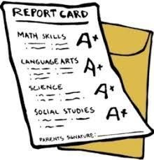**Grading Scale:**

E = Exceeding

S = Satisfactory

N = Needs Improvement

U= Unsatifactory

1. = Well Below Grade Level
2. = Below Grade Level

3= At Grade Level

4= Above Grade Level

**Assignment/Homework Policy:**

All assignments in class and sent home should be completed to the best of the scholar’s ability. The teacher is here to help scholars become academically successful, meaning we need to know what the scholar knows and doesn’t know. Therefore, the scholars should attempt to complete assignments independently. The scholars are also expected to read and practice math skills nightly, even when an assignment has not been given.

**What will scholars learn this year?**

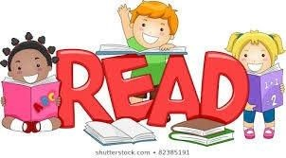**Reading:**

* + Print Concepts
  + Phonological Awareness
  + Phonics and Word Recognition
  + Fluency
  + describe characters, setting, plot
  + With prompting and support, ask and answer questions about key details in a text.
  + With prompting and support, retell familiar stories, including key details.
  + With prompting and support, identify characters, settings, and major events in a story.
  + Recognize common types of texts (e.g. storybooks, poems).
  + With prompting and support, define the role of the author and illustrator in telling the story.
  + Actively engage in group reading activities with purpose and understanding.
  + With prompting and support, describe the connection between two individuals, events, ideas, or pieces of information in a text.
  + Identify the front cover, back cover, and title page of a book
  + With prompting and support, describe how the words and illustrations work together to provide information
  + Actively engage in group reading activities with purpose and understanding

.

**Math:**

* + Counting and Cardinality
    1. Know number names and the count sequence

○ Count to tell the number of objects

○ Count to 100 by one and by tens

○ Write numbers from 0 to 20. Represent a number of objects with a written numeral 0-20

○ Compare two numbers between 1 and 10 presented as written numerals

○ Identify whether the number of objects in one group is greater than, less than, or equal to the number of objects in another group

○ Count forward beginning from a given number within the known sequence (instead of​ having to begin at 1)

* + Operations and Algebraic Thinking
    1. Represent addition and subtraction with objects, fingers, mental images, drawings, sounds

○ Solve addition and subtraction word problems, and add and subtract within 10

○ Decompose numbers less than or equal to 10 into pairs in more than one way

○ For any number from 1 to 9, find the number that makes 10​

○ Fluently add and subtract within 5 ● Numbers and Operations in Base Ten

○ Work with numbers 11-19 to gain foundations for place value

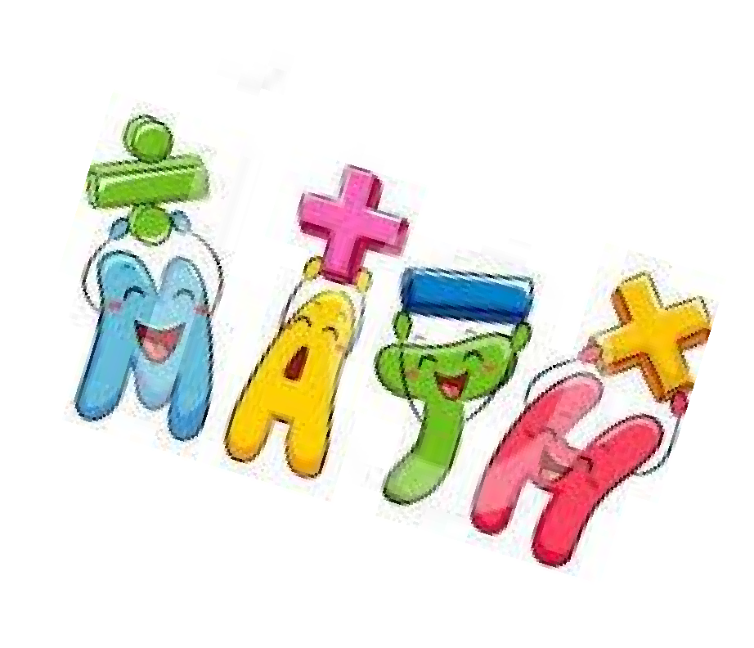○ Compose and decompose numbers from 11 to 19 into ten ones and some further ones

○ Record each composition or decomposition by a drawing or equation

○ understand that these numbers are composed of ten ones and one, two, three, four, five, six, seven, eight, or nine ones.

* + Measurement and Data
    1. Describe measurable attributes of objects, such as length or weight.

○ Describe several measurable attributes of a single object.

○ Directly compare two objects with a measurable attribute in common, to see which object has “more of”/“less of” the attribute, and describe the difference.

○ Classify objects into given categories; count the numbers of objects in each category and sort the categories by count.

* + Geometry
    1. Use terms such as above, below, beside, in front of, behind, and next to to describe objects

○ Correctly name shapes regardless of their orientations or overall size

○ Identify shapes as two-dimensional (lying in a plane, “flat”) or three-

dimensional (“solid”). Compose simple shapes to form larger shapes.

○ Analyze and compare two- and three-dimensional shapes, in different sizes and orientations, using informal language to describe number of sides and vertices/ “corners”) and other attributes (e.g., having sides of equal length).

**Writing:**

* + Opinion, Informative, Narrative
  + Digital Tools and resources
  + Research Projects
  + Recall Information



**Science:**

* + Forces and motion
  + Property of Matter
  + Earth Systems, Structures and Processes

● Structures and Functions of Living Organisms

**Social Studies:**

* + Understand Change over Time
  + Use Geographic representations and terms to describe surroundings.

● Understand the interaction between humans and the environment

● Understand basic economic concepts.

* + Understand the Roles of a Citizen.
  + Understand how Individuals Are similar and different.